IT24102269 – lab04 (PS)

Senesh K.H.M  
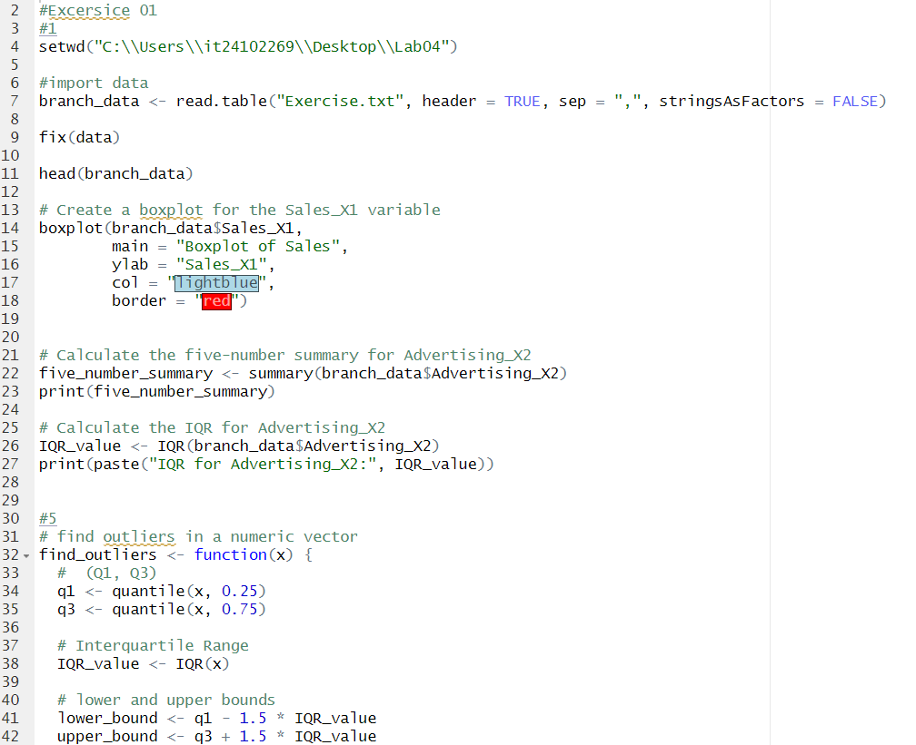

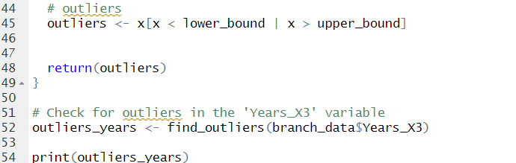

Question 2

**Branch**

Type – Categorical, (nominal)

Scale – Nominal

**Sales_X1**

Type – quantitative, continuous   
 Scale – Ratio

**Advertising_X2:**

Type: Quantitative (Continuous)

Scale: Ratio

**Years_X3:**

Type: Quantitative (Discrete)

Scale: Ratio